|  |  |  |  |
| --- | --- | --- | --- |
| 2 | | 58,087.142857142855 | |
| NUMERO DE FRONTERAS | | ENERGIA AGREGADA | |
|  | | | |
|  | |  | |
| CONTRATO | | VENCIMIENTO CONTRATO | |
|  | | | |
| 225,638,853 | 129 | | 9,183,316 |
| INGRESO 2020 | DÍAS CERTIFICADOS 2020 | | ENERGIA RESPALDADA 2020 |
|  | | | |
| 36,992,581 | 23 | | 1,646,976 |
| INGRESO 2021 | DÍAS CERTIFICADOS 2021 | | ENERGIA RESPALDADA 2021 |

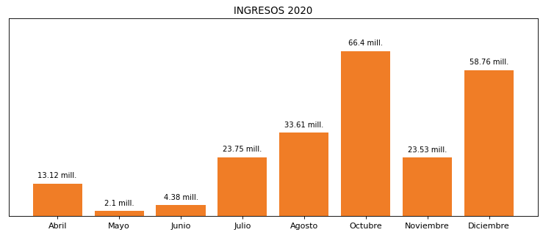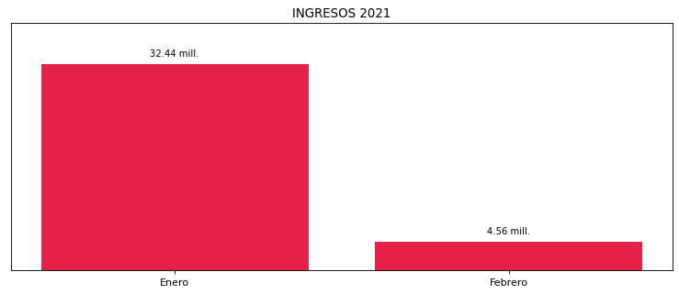

|  |
| --- |
| **VIDRIO ANDINO**  USUARIO |

|  |
| --- |
| **Juan Marin**  Ejecutivo de cuenta |

|  |
| --- |
| **Diego Moya / 0 / Diego.Moya@saint-gobain.com**  PUNTO FOCAL |

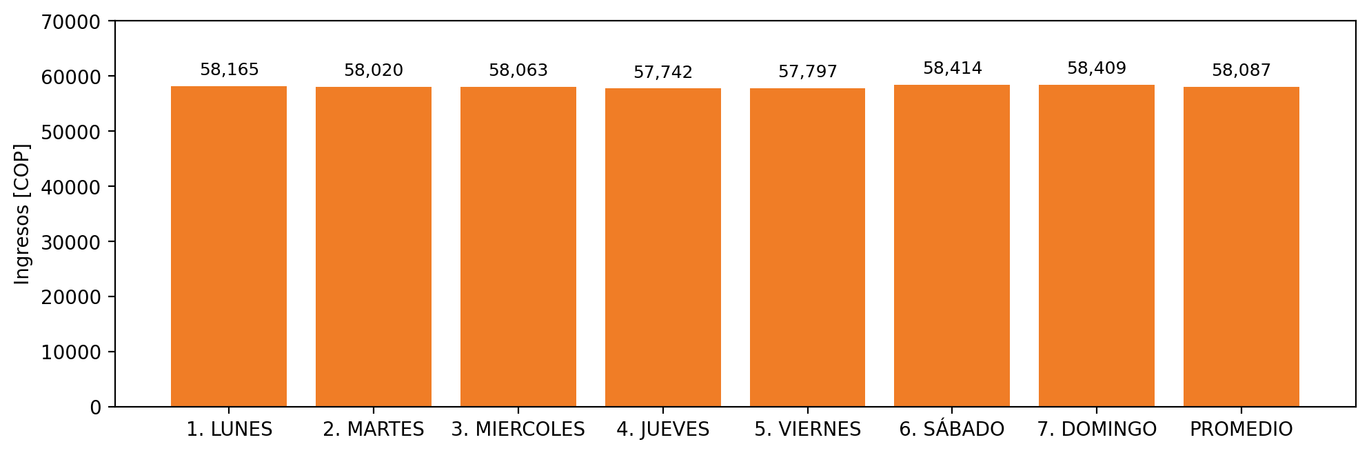

|  |  |  |  |  |  |  |  |  |  |  |
| --- | --- | --- | --- | --- | --- | --- | --- | --- | --- | --- |
| **FRONTERA** | **COD SIC** | **PREDIO** | **FRT DDV** | **TIPO DDV** | **PROMEDIO** | **PRÓXIMA ACTUALIZACIÓN** | **MARGEN DE ERROR** | **ÚLTIMA PRUEBA DDV** | **DÍAS PARTICIPACIÓN** | **FECHA REFERENCIA PRÓXIMA PRUEBA DDV** |
| VIDRIO ANDINO S.A | Frt19786 | Prd01603 | Frt36478 | LBC | 58,087 | 2022-03-08 | 4,29 | 2020-09-17 | 87.0 | 2021-12-05 |
| VIDRIO ANDINO S.A | Frt19785 | Prd01604 | Frt36479 | LBC | 58,087 | 2021-11-23 | 3,67 | 2020-11-09 | 67.0 | 2022-01-02 |